**P86**

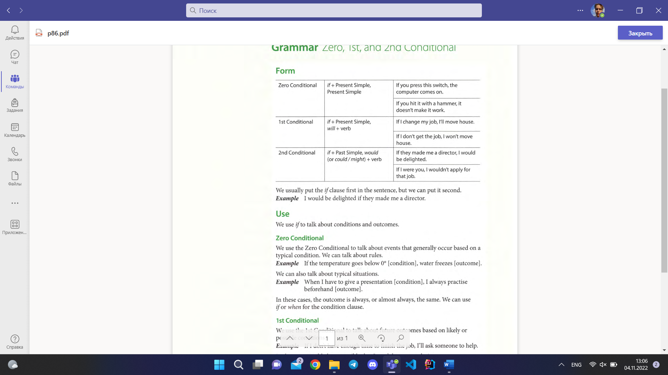

**P87**

**Task 1**

1. C
2. E
3. A
4. D
5. B

**Task 2**

1. Didn’t exist
2. Put
3. Would
4. Check / not relax
5. Went
6. Don’t read
7. Give up

**Task 3**

1. Would probably find
2. Knew
3. Work
4. Probably get
5. Would make
6. Offered
7. Don’t take
8. Moved
9. Will become
10. Stop

